**POTHOLE DETECTION AND CLASSIFICATION USING DEEP LEARNING**

Jasthi Lakshmi Narayana, Eshwar Sai Rayapati, Sravani Patnala,

Mohita,Pandikunta, Koushik Upputla, Saahas Myla

*School of Computer Science and Engineering*

*Lovely Professional University , ,, , Phagwara, Punjab, India*

[narayanjasthi@gmail.com](mailto:narayanjasthi@gmail.com), [reswarsai123@gmail.com](mailto:reswarsai123@gmail.com), [spatnala17@gmail.com](mailto:spatnala17@gmail.com),

[mohitha269@gmail.com](mailto:mohitha269@gmail.com), [saikoushik527@gmail.com](mailto:saikoushik527@gmail.com), [saahas719@gmail.com](mailto:saahas719@gmail.com)

**ABSTRACT:** **One of the most common kinds of road issues that need to be looked at before they can be fixed is potholes. It is one of the significant reasons for car crashes, alongside vehicle mileage. The collection and analysis of defects data will be used to evaluate road flaws. Despite the fact that fault evaluation based on the collected data is still performed by humans, data collection with various imaging devices is currently almost entirely automated. Pothole grouping and assessment by hand is tedious, costly, and work concentrated, dialing back the whole street fix process. This review portrays a strategy for recognizing and grouping potholes on street photographs using CNN, VGG, Densenet, Alexnet, ZFnet, Polynet, and xception for order and YOLOV5 for recognition. In order to organize the supplied input pictures into pothole and non-pothole groups in the suggested structure, we made use of a system based on convolutional neural networks and featuring pre-arranged models. Using the OpenCV Windows and Colab packages, 116 primitive photos were used to test the Python-created method. The aftereffects of seven separate pre-arranged models are examined and introduced in different ways with regards to precision, exactness, and audit measurements. The results show that the pre-set models InseptionResNetV2 and DenseNet201 are able to identify potholes in road photos with an accuracy of 89.66 percent.**

***Keywords – Pothole detection, Deep Learning, Transfer Learning***

1. **INTRODUCTION**

The road condition, which includes a pothole, and the accident are strongly connected. Detecting and avoiding road accidents is more difficult and difficult in India. Indian social and economic development depend on the road network. As per the examination, the Street Transport area Gross domestic product extended at a close to 10% yearly normal rate over the past decade, contrasted with a 6% yearly Gross domestic product development rate generally. India's government is currently rapidly building roads. Nonetheless, street upkeep is a troublesome endeavor because of insufficient waste and weighty trucks. Inadequate road maintenance results in the formation of potholes that lead to traffic collisions. Finding out how bad the road is in terms of problems is the first step toward quick road surface repair. The most common imperfection in street surfaces is potholes, which are bowl-molded openings of shifting measurements in the asphalt surface. Street mileage, the age of the street, extreme precipitation, materials' reactivity to environmental change, the utilization of inadequate development materials, and outside factors like unfortunate seepage and quality development the executives are factors that add to the arrangement of potholes out and about surface. pothole-harmed street surfaces, as portrayed in Fig. 1, have actually extended in India, as have stresses over potholes. A road that is well-kept always makes a big difference to the economy of the country.

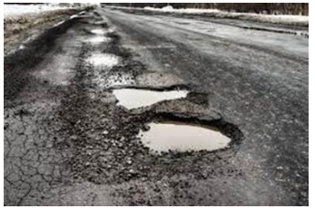

Fig.1: Example figure

Pothole detection can be done using a variety of models and methods. Potholes cannot be anticipated using the vibration approach, which relies on an accelerometer sensor. This is because the car needs to go over the pothole in order for it to be seen. This approach can't recognize potholes and other street antiquities, for example, span joints and street reflectors. 3D reconstruction approaches are the classification of laser scanning technologies. Potholes can be detected immediately by this device. In any case, such a sort is exorbitant and has a confined perceiving range. Sound system vision advancements are likewise utilized in pothole discovery. The requirement for amazing camera arrangement, vibration responsiveness, and the significant computational exertion expected for asphalt surface remaking are impediments of this innovation. The infrared innovation that supports the Kinect sensor was created by Microsoft. The sensor is said to be expensive and requires close proximity to the pothole. Finally, continuous pothole identification was achieved by vision-based structures employing a monocular camera and various item separating verification estimates.

1. **LITERATURE REVIEW**

**Pothole Detection Us- ing Computer Vision and Learning:**

To make it workable for continuous vehicle the board (for driver help or independent driving) or disconnected information assortment for street fix, techniques for identifying potholes on street surfaces are being created. Frameworks for distinguishing potholes on parkways have been totally read up by specialists overall consequently. Prior to partitioning laid out methods into various classifications, this review starts with a short outline of the subject. The improvement of calculations for programmed pothole recognition is then used to depict our commitments to the subject. Two methodologies in light of sound system vision examination of the street in front of the vehicle and two profound learning-based pothole ID models were created and tested. The four developed methods are the subject of an experimental evaluation, which leads to conclusions regarding their particular advantages.

**A Deep Learning Approach for Street Pothole Detection:**

Potholes are hollow structural damage to the road that can result in serious traffic collisions and lessen the efficiency of the road. An effective deep learning-based system for recognizing road potholes that can do so automatically is presented in this study. Four models are trained and tested using datasets that have been preprocessed: SSD, YOLO V3, faster R-CNN, and HOG with SVM. In stage one, first photographs with and without potholes are accumulated and marked. The four models are trained in step two, and their accuracy and loss are checked against the processed picture dataset. In the end, the performance and accuracy of all four models are evaluated. The results of the trial indicate that the YOLO V3 model performs better because it delivers detection results that are both quicker and more precise.

**Deep Learning Approach to Detect Potholes in Real Time using Smartphone:**

Recognizing and arranging potholes in an exact and helpful way is fundamental to hindering road disasters. As of now, street bothers are distinguished physically, which calls for investment and exertion. We present a framework that utilizes profound learning calculations and cellphones to recognize potholes continuously in this review. The cell phone application that maps the potholes along the client's all's ongoing course fills in as the framework's UI. A deep learning object recognizable proof calculation all the while: Utilizing a versatile camera, the Single Shot Multi-box Detector (SSD) searches for potholes behind the scenes. The database's coordinates are updated in real time whenever SSD detects an unregistered pothole. A Deep Feed Forward Neural Network model continuously collects and analyzes measurements from the accelerometer and gyroscope to identify unregistered potholes. This dual detection system, which employs both camera-based and accelerometer-gyroscope-based detection, not only performs cross-checks on detected objects, but it also produces consistent results even when one mechanism malfunctions. The map user interface, which is accessible within the same program, displays the pothole coordinates. A minimal expense and successful choice for constant pothole recognition, this framework has a guide/route capability toward the front and a two-overlay deep learning pothole recognizable proof calculation toward the back.

**A Deep Learning-Based Approach for Road Pothole Detection in Timor Leste:**

Using a convolutionalneural network (CNN), this study gives a negligible cost system to seeing road potholes pictures. Pictures taken from different areas with varieties, like blustery, dry, and obscure circumstances, act as the sole preparation ground for our model. Our model was able to simultaneously achieve (99.80%) Accuracy, Precision (100%), Recall (99.60%), and F-Measure (99.60%) in the evaluation conducted with 500 test images.

**YOLOv4: Optimal Speed and Accuracy of Object Detection:**

The accuracy of a Convolutional Neural Network (CNN) is supposed to be worked on by many qualities. Both hypothetical help for the outcomes and viable assessment of such element combos on enormous data sets are required. While some characteristics, such as lingering associations and bunch standardization, are applicable to the vast majority of models, tasks, and datasets, others are only relevant to specific models, concerns, or datasets with a limited scope. Weighted residual connections (WRC), cross-stage partial connections (CSP), cross mini-Batch normalization (CmBN), self-adversarial training (SAT), and mish-commencement are all thought to be examples of these ubiquitous properties. We achieve cutting-edge results by combining novel components like WRC, CSP, CmBN, SAT, Mish implementation, Mosaic information upgrading, CmBN, DropBlock regularization, and CIoU loss: 43.5% AP (65.7% AP50) on the Tesla V100 at a live rate of 65 FPS for the MS COCO dataset.

**3. METHODOLOGY**

The survey of the accessible writing recognizes three classes of pothole discovery frameworks: vision-based approaches, vibration-based procedures, and strategies in light of 3D reproduction In spite of the fact that vibration-based techniques are reasonable, they can't identify potholes in that frame of mind of a path or at span extension joints; The most common method of matching component focuses between two viewpoints requires a significant amount of computing power for sound system vision methods to recreate the asphalt surface, whereas 3D reconstruction-based solutions require modern, expensive hardware. Koch and Brilakis (2011), Kim and Ryu (2014), and H. Bello-Salau (2014) [2]-[4] give nitty gritty assessments of pothole identifying systems. The exactness of vision-based techniques is calculation subordinate and intensely subject to enter pictures.

We have used two modules for this project they are Deep learning model and the Website module.

**Deep learning model** are powerful for solving problems in machine learning and it is to provide better performance in detecting potholes.



fig2: user and system relation

**Disadvantages:**

Aparna and others [5] introduced a convolutional brain network for utilizing infrared symbolism to recognize potholes. With their self-constructed CNN engineering, the creators accomplished test exactness of 64.42 percent and 73.06 percent by two times changing different settings. The writers likewise evaluated a couple of ResNet models that had previously been prepared.

In this review, we present a robust, accuracy, and computationally cost effective pothole recognizable proof framework. A thick difference map is first changed to separate between street locales that have been harmed and those that haven't. Brilliant segment search and dynamic writing computer programs are utilized to gauge the change boundaries to increment divergence change proficiency. After that, the changed difference guide is dealt with using Otsu's thresholding method to identify potential street locations where people have been injured. A least-squares-fitted quadratic surface to deal with the differences in the extracted localities. To work on the heartiness of uniqueness map showcasing, the surface showing method also incorporates the surface typical. A random example agreement is also used to reduce the impact of anomalies. By looking at the uniqueness between the genuine and displayed divergence maps, potholes can be dependably distinguished.

**Advantages:**

At last, the recognized potholes' point surges are recovered from the revamped three-layered street surface. The consequences of the trials show that the recommended framework has a fruitful discovery accuracy of roughly 98:7 percent and an all out pixel-level accuracy of roughly 99:6 percent.

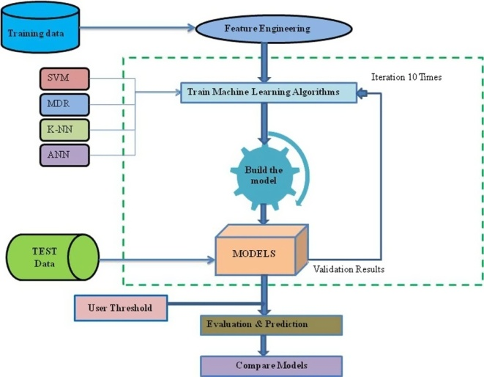

Fig.3: System architecture

**UML DIAGRAMS:**

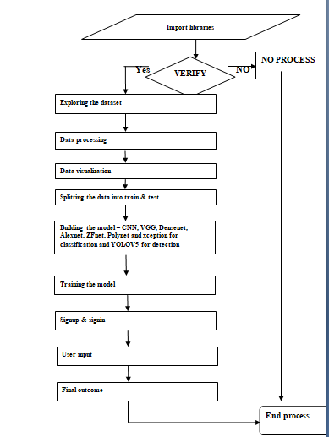

fig.4: Dataflow

**MODULES:**

Our project's use of modules are:

Investigation of information: This module will be utilized to enter information into the framework.

Dealing with: Using this module, we will scrutinize data for taking care of.

Data division into train and test: Using this module, we will disconnect the data into train and test.

for characterization: CNN, VGG, Densenet, Alexnet, ZFnet, Polynet, and xception; for recognition, YOLOV5. Decided estimation precision

Client data trade and login: By utilizing this module, you can enroll and sign in.

Client input: Forecast information will come about because of utilizing this module.

Forecast: The last expected worth will be made accessible.

**4. IMPLEMENTATION**

CNN: CNN is a deep learning model intended to naturally and adaptively gain spatial orders of data from low-level examples to undeniable level examples for handling information with a lattice design, similar to photos [13, 14].

VGG: The diverse deep Convolutional Neural Network (CNN) design referred to as VGG is curtailed as VGG. The quantity of convolutional layers in VGG-16 or VGG-19 is intended to be alluded to as the "deep." The cutting edge object affirmation models depend on the VGG plan.

DenseNet: A DenseNet is a sort of convolutional neural network that uses thick relationship between layers through Thick Blocks, which interface all layers (with matching component map sizes) directly with each other.

AlexNet: Five convolutional layers, three max-pooling layers, two normalization layers, two fully related layers, and one softmax layer make up the AlexNet architecture. 2. ReLU is constrained in each convolutional layer by convolutional channels and a nonlinear foundation. 3. The most crucial pooling is carried out using the pooling layers.

ZFNet: A customary convolutional brain organization, ZFNet Imagining center part layers and the working of the classifier persuaded the arrangement. The convolutions' step and channel widths are decreased in contrast with AlexNet.

Xception: Xception is a deep convolutional neural network with 71 layers. It is plausible to stack a pretrained variation of the association that was ready on in excess of a million pictures from the ImageNet data base [1]. Photos of control center, mice, pencils, and various animals can be set up into one of 1,000 remarkable thing orders by the pretrained network.

YOLOV5: Model of PC vision YOLOv5 is a member of the You Only Look Once (YOLO) family. For object disclosure, YOLOv5 is widely used. There are four sizes of YOLOv5: small (s), medium (m), large (l), and extra large (x), with each offering expanding levels of accuracy.

**Website Module** comprises of a set of files including three PHP files, HTML and CSS files, images, and a SQL database. Where HTML & CSS are used to make the form accessible for users which provides user interface to display the forms and queries. Bootstrap is used for input form. PHP is used here to handle the server-side logic and database interactions.

**5. EXPERIMENTAL RESULTS**



fig.5: Home screen



fig.6: User registration



fig.7: User login



fig.8: Main page

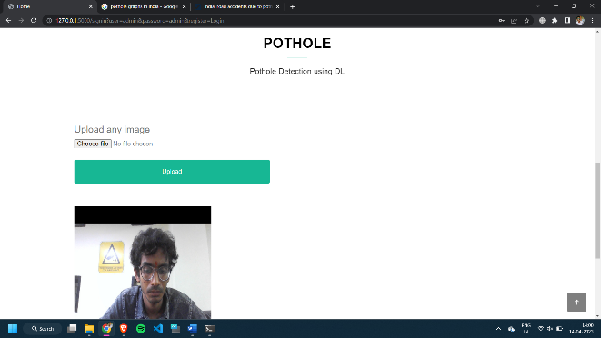

fig.9: User input-1

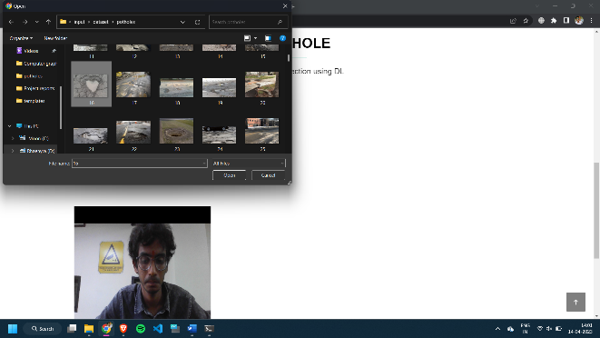

fig 10: user input-2

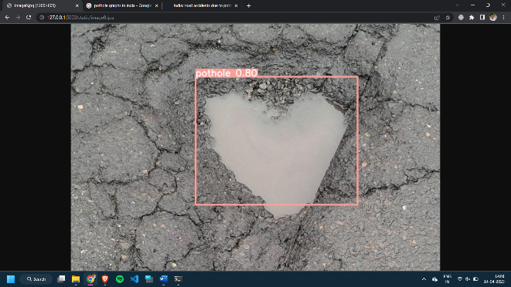

fig.10: Prediction result

**6. CONCLUSION**

The uniqueness map demonstrating approach and a clever divergence change strategy are the essential commitments of this paper. While utilizing our strategy, whole street locales are simpler to distinguish on the changed over uniqueness map and can be immediately recovered utilizing Otsu's limit approach. The power of difference map demonstrating is fundamentally worked on subsequently. To additionally foster dealing with execution, the change limits were evaluated using GSS and DP. During the dissimilarity map demonstrating process, variations with essentially unique ordinary vectors from the ideal one were additionally barred, improving the precision of the displayed difference map much further. Finally, the potholes were recognized by differentiating the uniqueness guides of the certifiable and showed data. The point billows of the found potholes were then recovered from the reproduced three-layered street surface. To help with investigations of sound system vision-based pothole recognition, we have made three datasets. According on the early disclosures, our suggested computation has an overall productive acknowledgment accuracy of approximately 98.7% and pixel-level accuracy of around 99.6%.

**REFERENCES**

[1] J. S. Miller and W. Y. Bellinger, “Distress identification manual for the long-term pavement performance program,” United States. Federal Highway Administration. Office of Infrastructure Research and Development, Tech. Rep., 2014.

[2] S. Mathavan, K. Kamal, and M. Rahman, “A review of threedimensional imaging technologies for pavement distress detection and measurements,” IEEE Transactions on Intelligent Transportation Systems, vol. 16, no. 5, pp. 2353–2362, 2015.

[3] T. Kim and S.-K. Ryu, “Review and analysis of pothole detection methods,” Journal of Emerging Trends in Computing and Information Sciences, vol. 5, no. 8, pp. 603–608, 2014.

[4] R. Fan, J. Jiao, J. Pan, H. Huang, S. Shen, and M. Liu, “Real-time dense stereo embedded in a uav for road inspection,” in Proceedings of the IEEE Conference on Computer Vision and Pattern Recognition Workshops, 2019, pp. 0–0.

[5] C. Koch, K. Georgieva, V. Kasireddy, B. Akinci, and P. Fieguth, “A review on computer vision based defect detection and condition assessment of concrete and asphalt civil infrastructure,” Advanced Engineering Informatics, vol. 29, no. 2, pp. 196–210, 2015.

[6] Y.-C. Tsai and A. Chatterjee, “Pothole detection and classification using 3d technology and watershed method,” Journal of Computing in Civil Engineering, vol. 32, no. 2, p. 04017078, 2017.

[7] I. Pitas, Digital image processing algorithms and applications. John Wiley & Sons, 2000.

[8] S. Li, C. Yuan, D. Liu, and H. Cai, “Integrated processing of image and gpr data for automated pothole detection,” Journal of computing in civil engineering, vol. 30, no. 6, p. 04016015, 2016.

[9] E. Buza, S. Omanovic, and A. Huseinovic, “Pothole detection with image processing and spectral clustering,” in Proceedings of the 2nd International Conference on Information Technology and Computer Networks, 2013, pp. 48–53.

[10] C. Koch and I. Brilakis, “Pothole detection in asphalt pavement images,” Advanced Engineering Informatics, vol. 25, no. 3, pp. 507–515, 2011.

[11] M. R. Jahanshahi, F. Jazizadeh, S. F. Masri, and B. Becerik-Gerber, “Unsupervised approach for autonomous pavement-defect detection and quantification using an inexpensive depth sensor,” Journal of Computing in Civil Engineering, vol. 27, no. 6, pp. 743–754, 2012.

[12] R. Fan, X. Ai, and N. Dahnoun, “Road surface 3D reconstruction based on dense subpixel disparity map estimation,” IEEE Transactions on Image Processing, vol. PP, no. 99, p. 1, 2018.

[13] C. Zhang and A. Elaksher, “An unmanned aerial vehicle-based imaging system for 3d measurement of unpaved road surface distresses,” Computer-Aided Civil and Infrastructure Engineering, vol. 27, no. 2, pp. 118–129, 2012.

[14] R. Fan, “Real-time computer stereo vision for automotive applications,” Ph.D. dissertation, University of Bristol, 2018.

[15] Z. Zhang, X. Ai, C. Chan, and N. Dahnoun, “An efficient algorithm for pothole detection using stereo vision,” in Acoustics, Speech and Signal Processing (ICASSP), 2014 IEEE International Conference on. IEEE, 2014, pp. 564–568.